OUTPUT
TASK 1: COUNT TOTAL RIDES
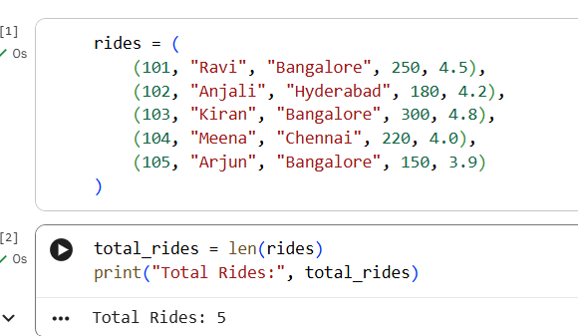
TASK 2 : EXTRACT ALL RIDES FROM BANGALORE
TASK 3:FIND TOTAL REVENUE FROM BANGALORE
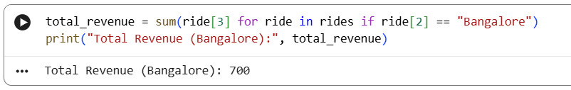
TASK 4: FIND HIGHEST RATED DRIVER
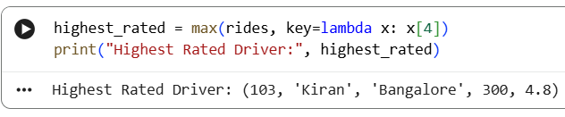
TASK 6: AVERAGE RATING PER CITY
